SIMATS ENGINEERING
SAVEETHA INSTITUTE OF MEDICAL AND TECHNICAL SCIENCES
CHENNAI – 602105
Department of Computer Science and Engineering

ASSESSMENT TOOL 3 – Correlation and Pattern Analysis

Course Code: | DSA0502 | Course Title: | Query Processing for Data Science
CO Assessed: | CO4 | Assessment: | Tool 3– Correlation and Pattern Analysis
Weightage: | 25% | Total Marks:
CO4 Statement: Explore datasets using analytical techniques such as grouping, correlation detection, joining datasets, and extracting meaningful insights.
Student Name: | SIDDARTH P | Reg. No.: | 192324264
Section / Batch: | 2023 | Date of Submission:
Faculty In-charge: | Dr. B.Shyamala Gowri | Project Mode: | Individual Submission

Code of Conduct
I_SIDDARTH P / 192324264_ (Name / Reg No) certify that this submission is my original work and that I have adhered to all guidelines specified for this assessment. I understand that any violation of academic integrity rules will result in disciplinary action.
Signature: SIDDARTH P

Question 4 – Geographical Pattern and Correlation Analysis
The analysis uses location, population, income, sales and customer-density information. Two tables are joined using Location, followed by correlation analysis, performance grouping, outlier detection and geographical visualization.

1. Dataset Preparation and Import
Two structured datasets are used. The demographic table contains location, population, income, customer density and coordinates. The sales table contains location, sales and order information.

import pandas as pd
demographic = pd.read_csv("demographic_data.csv")
sales = pd.read_csv("sales_data.csv")
print(demographic.head())
print(sales.head())
print(demographic.info())
print(sales.info())

Location | Population_M | Income_000_USD | Customer_Density
Chennai | 7.10 | 420 | 86
Bengaluru | 8.50 | 510 | 104
Hyderabad | 6.80 | 395 | 82
Mumbai | 12.50 | 620 | 150
Delhi | 11.00 | 575 | 132
Pune | 4.20 | 455 | 96
Kolkata | 4.50 | 360 | 75
Ahmedabad | 5.60 | 410 | 88

2. Joining the Datasets
The two tables are combined using an inner join on Location. This keeps locations that are present in both datasets and produces one analysis table.

df = demographic.merge(
sales,
on="Location",
how="inner"
)
print(df.head())
print(df.shape)

Location | Population_M | Income_000_USD | Customer_Density | Sales_M | Orders
Chennai | 7.10 | 420 | 86 | 58.40 | 14200
Bengaluru | 8.50 | 510 | 104 | 73.50 | 17600
Hyderabad | 6.80 | 395 | 82 | 54.20 | 13100
Mumbai | 12.50 | 620 | 150 | 98.60 | 23100
Delhi | 11.00 | 575 | 132 | 91.70 | 21500
Pune | 4.20 | 455 | 96 | 66.10 | 15800
Kolkata | 4.50 | 360 | 75 | 43.80 | 10400
Ahmedabad | 5.60 | 410 | 88 | 61.20 | 14600
Jaipur | 3.90 | 335 | 68 | 38.90 | 9100
Kochi | 2.10 | 390 | 91 | 47.60 | 11200
Coimbatore | 2.20 | 345 | 73 | 42.70 | 9800
Lucknow | 3.70 | 315 | 61 | 34.50 | 8200

3. Correlation Analysis
Pearson correlation is calculated for population, income, sales, customer density and order count. Values closer to +1 indicate a strong positive relationship, while values closer to -1 indicate a strong negative relationship.
corr = df[
[
"Population_M",
"Income_000_USD",
"Sales_M",
"Customer_Density",
"Orders"
]
].corr()
print(corr.round(2))

Variable | Population_M | Income_000_USD | Sales_M | Customer_Density | Orders
Population_M | 1.00 | 0.89 | 0.90 | 0.85 | 0.90
Income_000_USD | 0.89 | 1.00 | 0.99 | 0.98 | 0.99
Sales_M | 0.90 | 0.99 | 1.00 | 0.97 | 1.00
Customer_Density | 0.85 | 0.98 | 0.97 | 1.00 | 0.96
Orders | 0.90 | 0.99 | 1.00 | 0.96 | 1.00

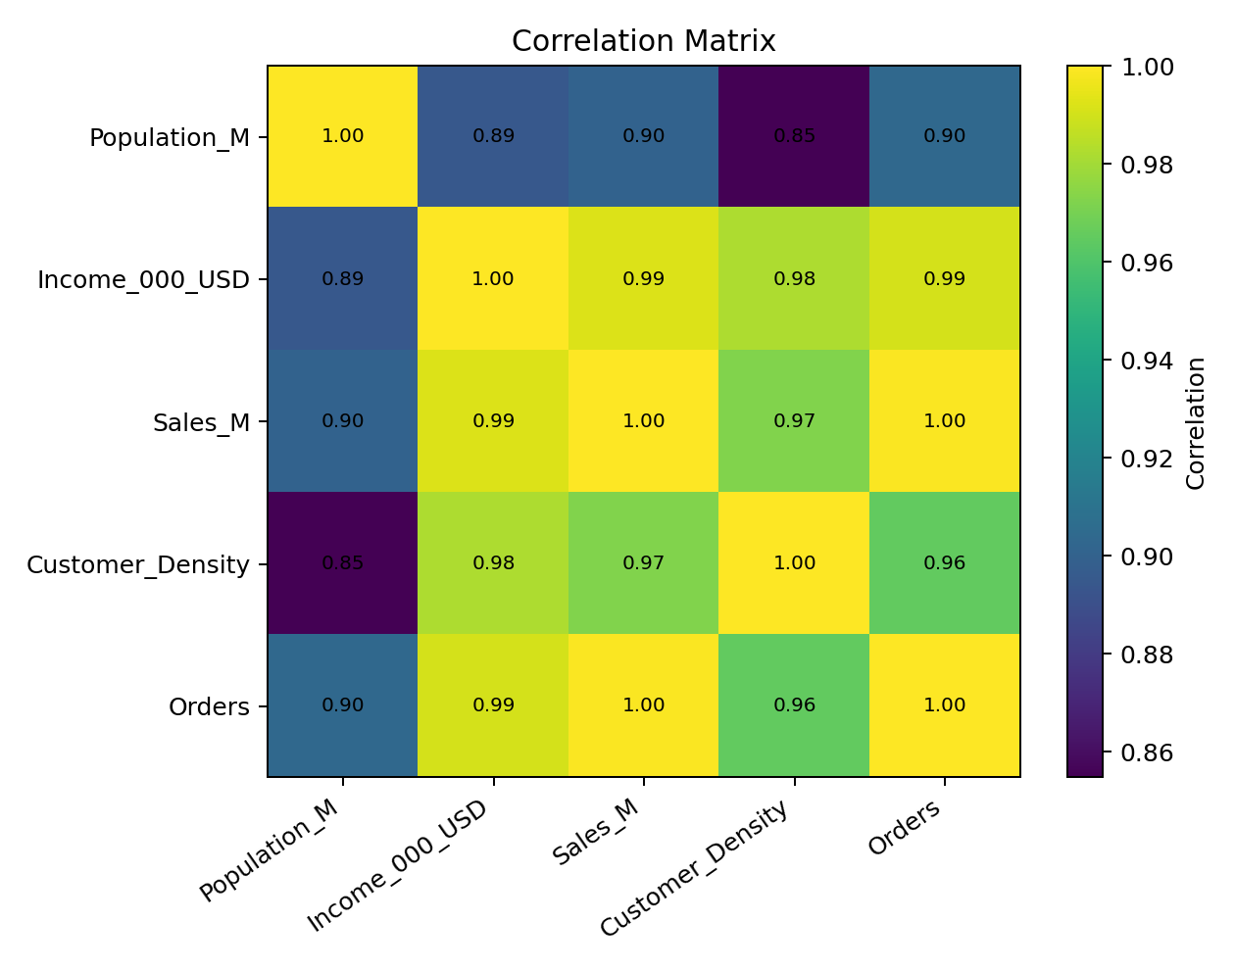
The strongest relationship with Sales_M in this dataset is Income_000_USD with a correlation of 0.99. Population and customer density also show positive relationships with sales.

4. Grouping Locations by Performance
Locations are divided into three performance groups using sales tertiles. This provides a simple comparison between low-, medium- and high-performing locations.

df["Performance_Group"] = pd.qcut(
df["Sales_M"],
q=3,
labels=[
"Low Performance",
"Medium Performance",
"High Performance"
]
)
group_summary = df.groupby(
"Performance_Group",
observed=True
)[
["Sales_M", "Population_M",
"Income_000_USD", "Customer_Density"]
].mean()
print(group_summary.round(2))

Performance_Group | Sales_M | Population_M | Income_000_USD | Customer_Density
Low Performance | 39.98 | 3.58 | 338.75 | 69.25
Medium Performance | 55.35 | 5.40 | 403.75 | 86.75
High Performance | 82.48 | 9.05 | 540.00 | 120.50

5. Outlier Detection
The IQR method is applied to Sales_M. A value below Q1 − 1.5×IQR or above Q3 + 1.5×IQR is treated as a potential outlier.

q1 = df["Sales_M"].quantile(0.25)
q3 = df["Sales_M"].quantile(0.75)
iqr = q3 - q1
lower = q1 - 1.5 * iqr
upper = q3 + 1.5 * iqr
outliers = df[
(df["Sales_M"] < lower) |
(df["Sales_M"] > upper)
]
print(outliers)

Q1 is 43.52 million and Q3 is 67.95 million, giving an upper IQR limit of 104.59 million.
No location falls outside the IQR limits in the selected dataset.
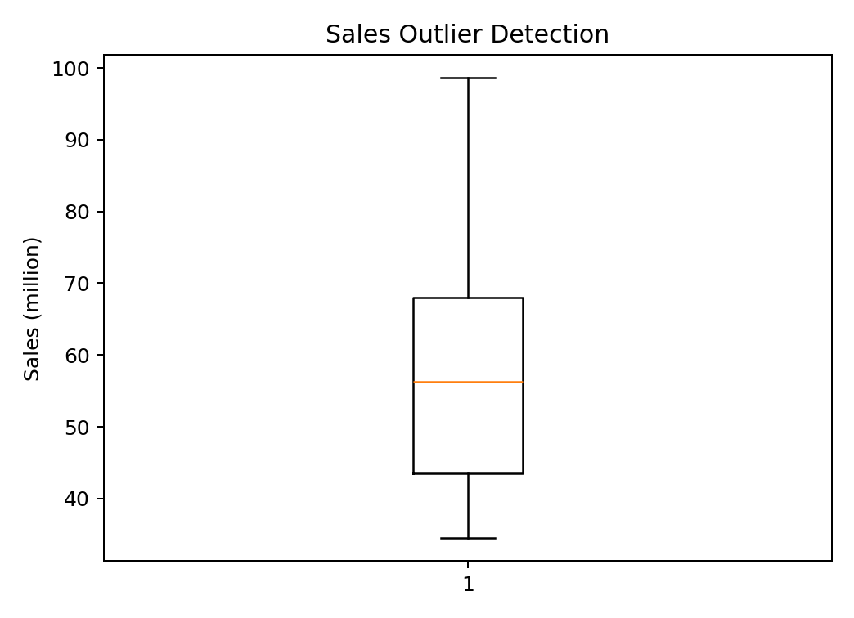

6. Geographical Pattern Analysis
Latitude and longitude are used to place each location on a geographical plot. Marker size and label position help compare sales across locations.
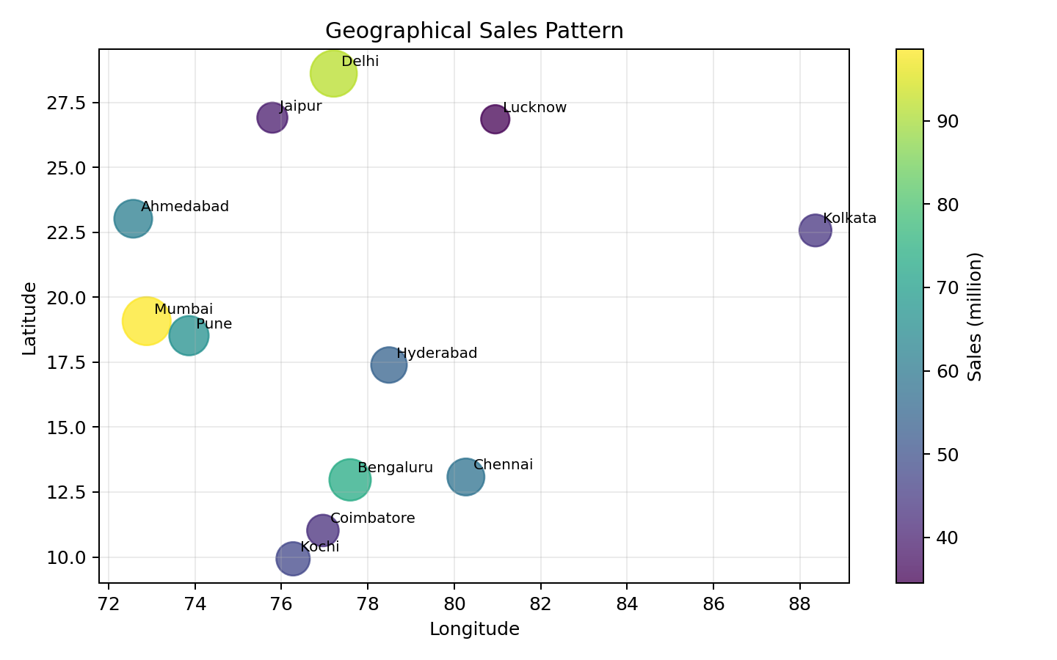

7. Supporting Visualizations
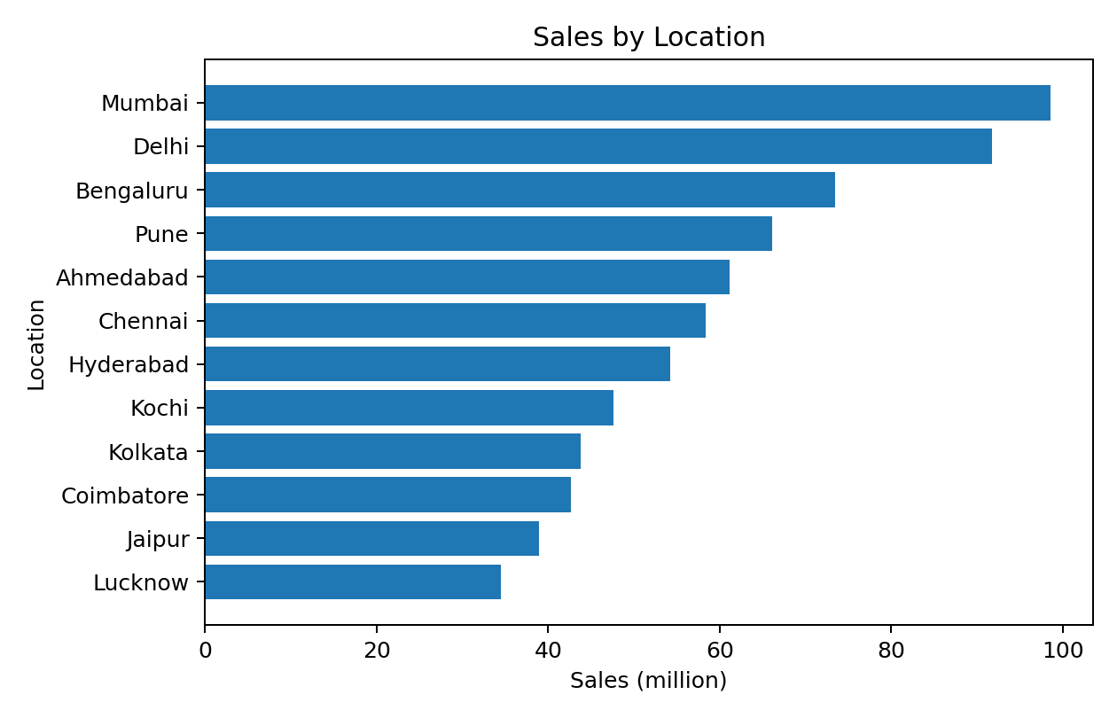
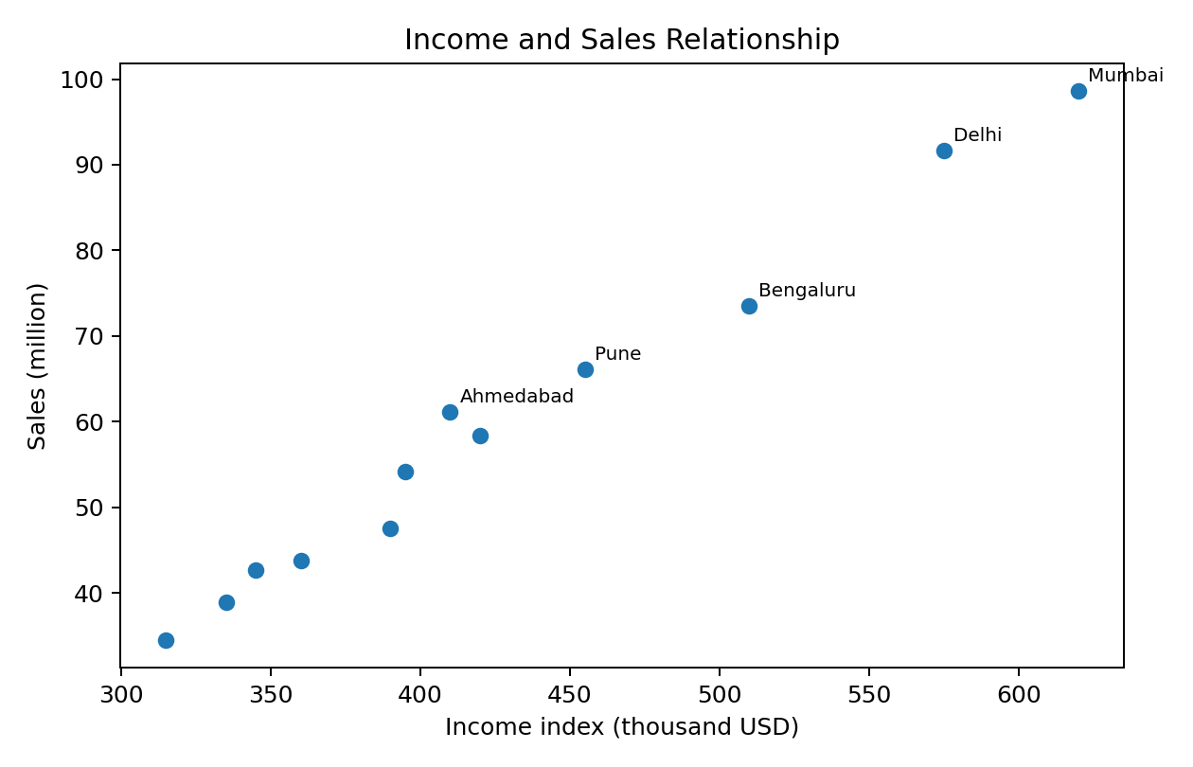
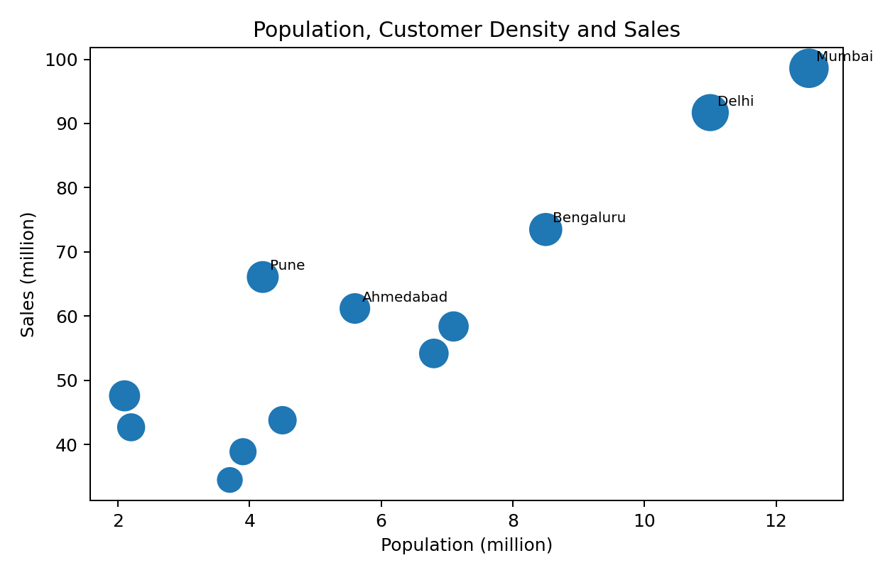

8. Key Findings
- Mumbai has the highest sales in the prepared dataset at 98.6 million.
- Income and sales have a positive correlation of 0.99, indicating that higher-income locations generally record higher sales in this sample.
- Population and sales have a correlation of 0.90, showing a positive relationship between market size and sales.
- Customer density and sales have a correlation of 0.97, indicating that denser customer markets tend to support higher sales.
- The performance grouping separates locations into low, medium and high sales segments for easier comparison.

9. Conclusion
The joined geographical dataset shows how demographic and customer factors can be related to sales performance across locations. Correlation identifies the strongest relationships, grouping separates locations by performance, and IQR analysis checks for unusual sales values. The geographical plot makes the spatial pattern easier to interpret.

10. Interactive Map Code
A simple Folium map can be opened in a browser to inspect each location interactively. The popup displays sales, income and customer-density values.
import folium
m = folium.Map(
location=[21.0, 78.0],
zoom_start=5
)
for _, row in df.iterrows():
folium.CircleMarker(
location=[
row["Latitude"],
row["Longitude"]
],
radius=max(5, min(18, row["Sales_M"] / 6)),
popup=(
f"{row['Location']}<br>"
f"Sales: {row['Sales_M']:.1f} M<br>"
f"Income: {row['Income_000_USD']:.0f}<br>"
f"Customer density: {row['Customer_Density']:.0f}"
),
tooltip=row["Location"],
fill=True
).add_to(m)
m.save("interactive_sales_map.html")

